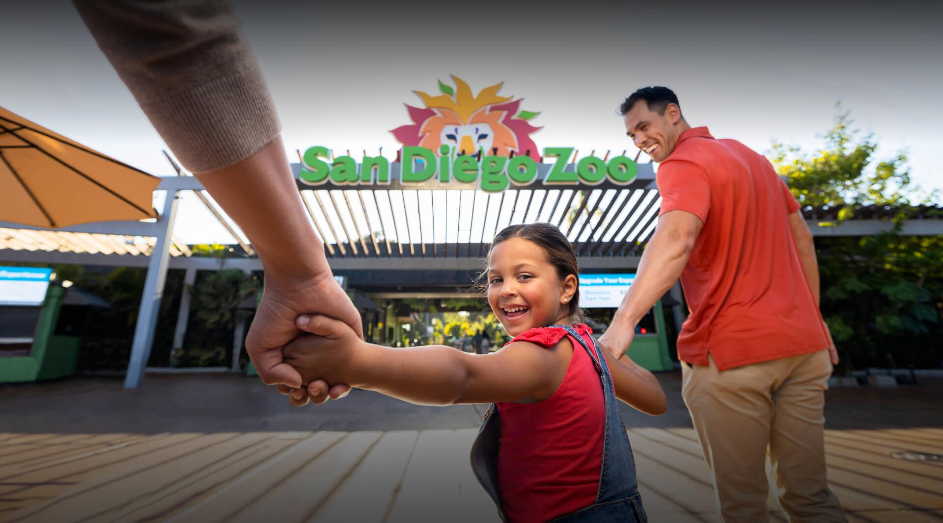

About Sandiego Zoo Park

What is Sandiego Park Zoo? and where is located established? The San Diego Zoo is one of the most famous and largest zoos in the world, known for its extensive collection of animals and commitment to wildlife conservation.

The zoo is situated in Balboa Park, in the city of San Diego, California, USA.The San Diego Zoo was officially founded in 1916, following the Panama-California Exposition held in 1915–1916.

Opening & Closed Timings

The zoo is typically open every day from 9:00 AM to 6:00 PM.

During peak seasons (like summer and holidays), the zoo may extend its hours. It’s always a good idea to check the official website for the most current timings.

Animal shows and encounters are scheduled throughout the day, with times varying based on season and animal activity. The zoo’s schedule for animal experiences is available at the entrance or online Family-Friendly Features.

The zoo offers family-oriented programs and camps for kids, including day camps, overnight camps, and educational programs. These programs allow children to engage in fun and educational experiences related to animals, conservation, and the natural world.

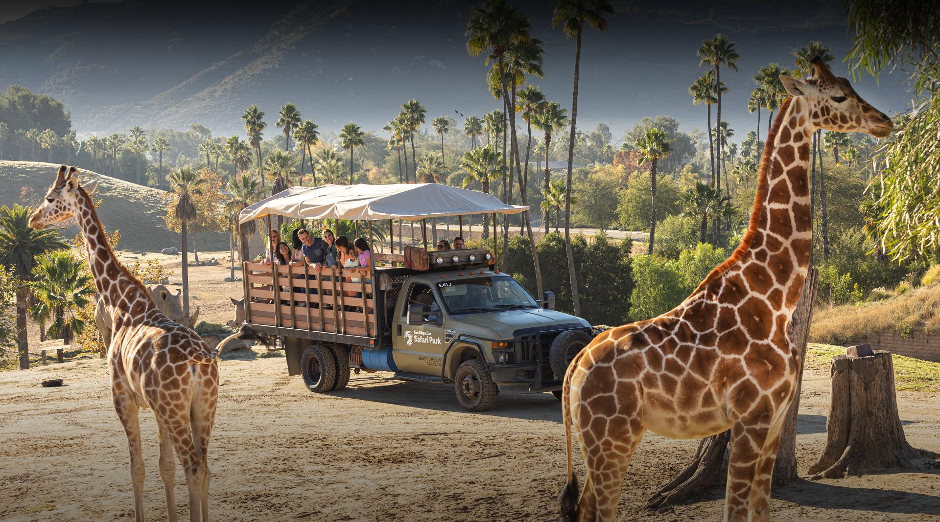

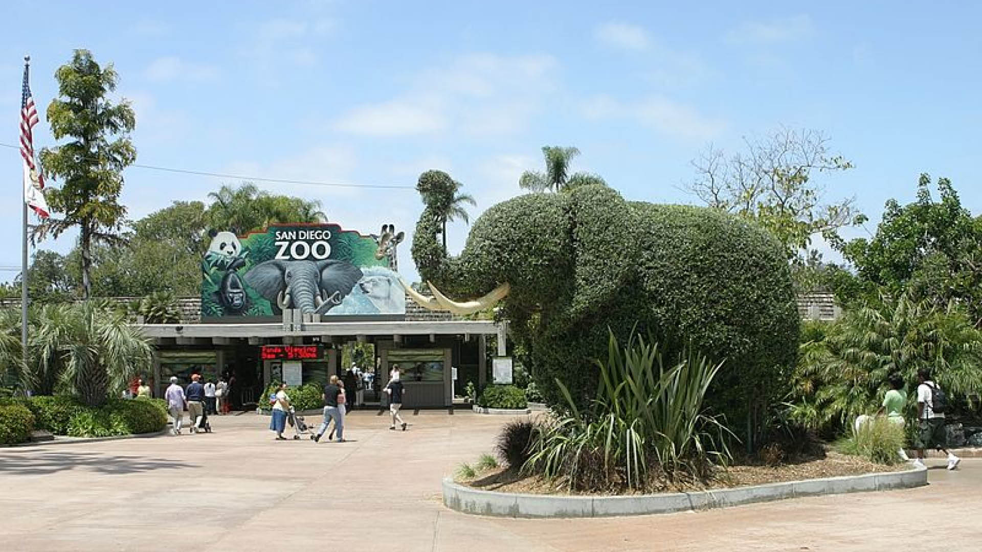

Animals List

Komodo Dragons

Koalas

Arabian oryx

Flamingos

Polar bear

Tigers

Gorillas

Monkeys

Address & Contact

Address: The San Diego Zoo is located at 2920 Zoo Drive, Sandiego, California 92101. For questions related to visiting, opening times, directions, accessibility, or other general information, you can visit their [Support Centre](https://www.Sandiegozoo.org/about-us/contact-london-zoo).

Email: For specific enquiries Media personnel can contact the Public Relations department at SDZWAPublicRelations@SDZWA.org.

Phone: For urgent enquiries, you can call their Supporter Contact team at (619) 718-3000.

For the most accurate and up-to-date information, it's recommended to visit the [official Sandiego Zoo website]( https://zoo.sandiegozoo.org).